PG Department of Botany
S. NO | NAME OF STUDENT | College Roll No | CLASS | Marks in University Exams/House Tests in Previous year/Semester |  | Measures Taken/opportunities given to Further enhance skills and confidence of the students | ACHIEVMENTS | PROOF
1 | YASHIKA ARORA | 20101 | B.Sc Sem1 (Medical) | 16/20 | 19/20 | 1. Give extra books from departmental library for vast knowledge about the topics.  2. Given assignments & checked by concerned teachers covering important topics fromthe syllabus. | Participation in National Science Week In Hans Raj Mahila Maha Vidyalaya Jalandhar | 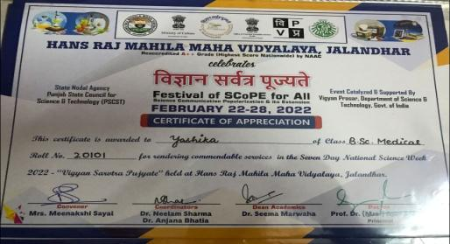
 | Yashika Arora | 20101 | B.Sc Sem1 (Medical) | 16/20 | 19/20 | - Encouraged to participate in different online activities organised during the session.  2 .Provided important questions from previous years question paper.  3.Students were motivated to enroll for MOOCS/NPTEL courses. | Certificate Of Merit In Power Point Presentation Competition Held April 2022 in Layallapur Khalsa College Jlandhar | 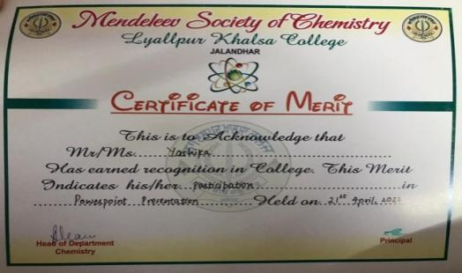
3 | Yashika Arora | 20101 | B.Sc Sem1 (Medical) | 16/20 | 19/20 | 1. Encouraged to participate in different online activities organised during the session.  2. Provided important questions from previous years question paper.  3. Students were motivated to enroll for MOOCS/NPTEL courses. | 1ST Position  Choreography Event Held in  National Science Week 2022 In Hans Raj Mahila Maha Vidyalaya Jalandhar | 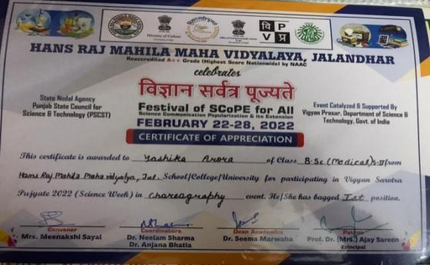
4 | Yashika Arora | 20101 | B.Sc Sem1 (Medical) | 16/20 | 19/20 | 1. Given extra books from departmental library for vast knowledge about the topics.  2.Given assignments & checked by concerned teachers covering important topics from the syllabus. | 3RD Position in ‘Exploravision –write-up’ on National Science Day 2022 held in KMV College Jalandhar | 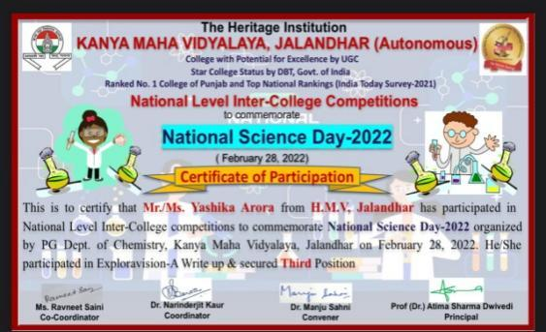
5 | Yashika Arora | 20101 | B.Sc Sem1 (Medical) | 16/20 | 19/20 | 1. Encouraged to participate in different online activities organised during the session.  2. Provided important questions from previous years question paper.  3. Students were motivated to enroll for MOOCS/NPTEL courses. | Consolation prize in PPT ON WILD LIFE competition on Wild Life Week celebration held in Hans Raj Mahila Maha Vidyalaya Jalandhar | 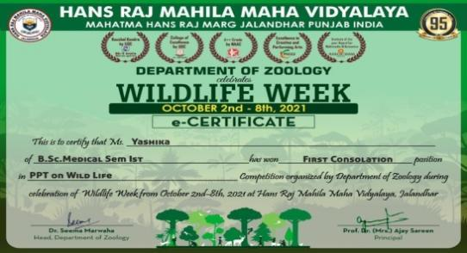
6 | Yashika Arora | 20101 | B.Sc Sem1 (Medical) | 16/20 | 19/20 | 1.Give extra books from departmental library for vast knowledge about the topics.  2.Given assignments & checked by concerned teachers covering important topics fromthe syllabus. | Certificate of Participation in Omicorn Awareness Quiz organized by Vivekanand College Madurai | 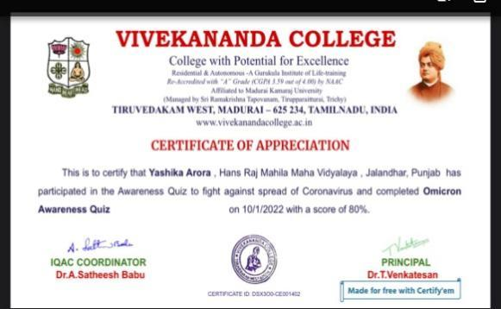
7 | Yashika Arora | 20101 | B.Sc Sem1 (Medical) | 16/20 | 19/20 | - Encouraged to participate in different online activities organised during the session.  2. Provided important questions from previous years question paper.  3.Students were motivated to enroll for MOOCS/NPTEL courses. | Certificate of Merit on Environment Health Day organized by Botany Department KMV College Jalandhar | 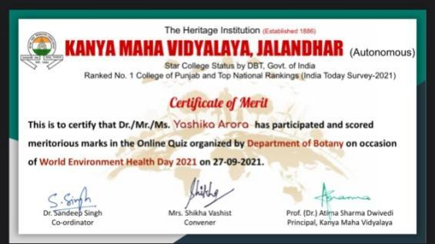
8 | Simranjeet kour | 201010 | B.Sc Sem11 (Medical) | 17/20 | 20/20 | 1. Given extra books from departmental library for vast knowledge about the topics.  2. Given assignments & checked by concerned teachers covering important topics fromthe syllabus. | Certificate of Participation in Say no to Pledge | 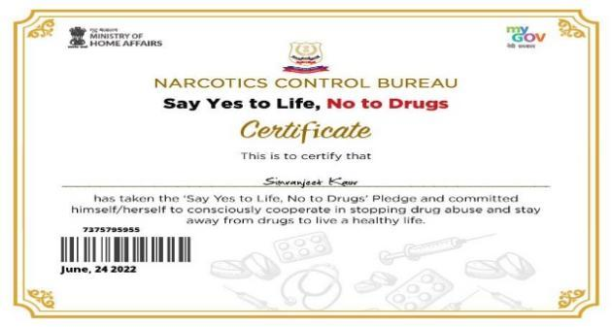
9 | Gulnar | 20107 | B.Sc Sem11 (Medical) | 18/20 | 20/20 | - Encouraged to participate in different online activities organised during the session.  2.Provided important questions from previous years question paper.  3.Students were motivated to enroll for MOOCS/NPTEL courses. | Participation in National Science Week In Hans Raj Mahila Maha Vidyalaya Jalandhar | 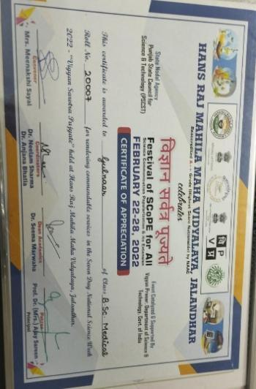
10 | Simran | 201010 | B.Sc Sem11 (Medical) | 16/20 | 19/20 | 1.Give extra books from departmental library for vast knowledge about the topics.  2.Given assignments & checked by concerned teachers covering important topics fromthe syllabus. | Participated in Participation In  ICPBEC-2021 held in  Hans Raj Mahila Maha Vidyalaya Jalandhar | 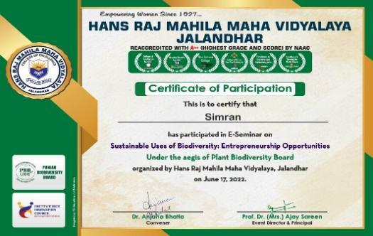
11 | Simranjeet Kour | 201010 | B.Sc Sem11 (Medical) | 17/20 | 20/20 | - Encouraged to participate in different online activities organised during the session.  2. Provided important questions from previous years question paper.  3.Students were motivated to enroll for MOOCS/NPTEL courses. | Attended Combined Annual Training Camp in Phagwara and won best Firer in Camp. | 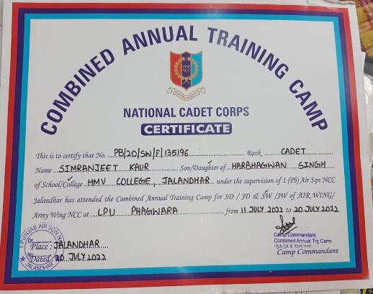
PG Students
1 | Bishakha Sharma , | M.Sc. SEM 4 |  | 18/20 |  | 1. Given extra books from departmental library for vast knowledge about the topics.  2. Given assignments & checked by concerned teachers covering important topics from the syllabus. | Participation Certificate in Quiz Competition organized by Chanderyan Vipnet Club HMV College Jalandhar | 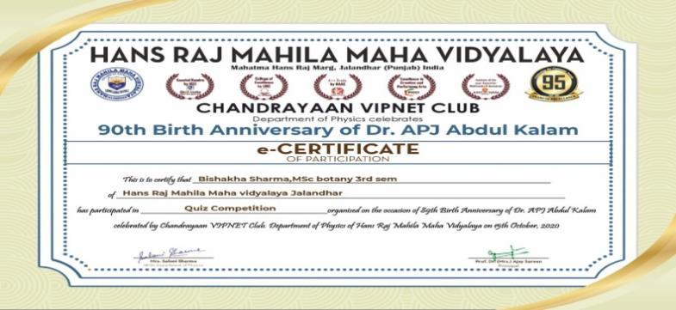
2 | Bishakha Sharma |  |  | 18/20 |  | - Encouraged to participate in different online activities organised during the session.  2.Provided important questions from previous years question paper.  3.Students were motivated to enroll for MOOCS/NPTEL courses. | Participation In ICPBEC-2021 held in HMV College Jalandhar | 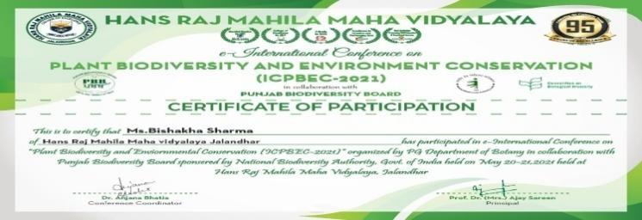
3 | Amarpreet Kour | M.Sc. SEM 4 |  | 19/20 |  | 1.Give extra books from departmental library for vast knowledge about the topics.  2.Given assignments & checked by concerned teachers covering important topics fromthe syllabus. | First Position In Poster Competition In ICPBEC 2021 2021held in HMV College Jalandhar | 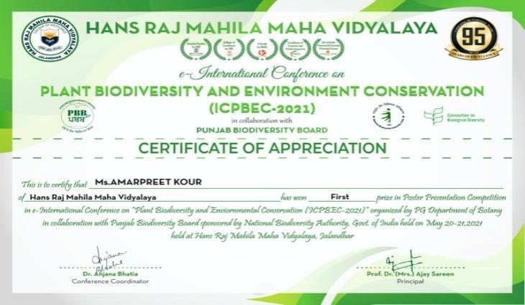
4 | Paviterdeep | M.Sc. SEM 4 |  | 19/20 |  | - Encouraged to participate in different online activities organised during the session.  2.Provided important questions from previous years question paper.  3.Students were motivated to enroll for MOOCS/NPTEL courses. | Participation In Scientific Rangoli In Chemcare organized by R. Venkatraman Chemical Society held in HMV College Jalandhar | 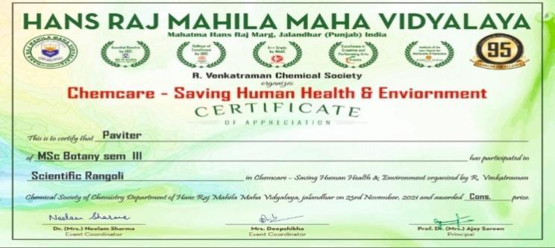
5 | Bishakha Sharma | M.Sc. SEM 4 |  | 18/20 |  | 1.Give extra books from departmental library for vast knowledge about the topics.  2.Given assignments & checked by concerned teachers covering important topics fromthe syllabus. | Participation certificate in E- Seminar On Sustainable Use of Biodiversity organized in HMV College Jalandhar | 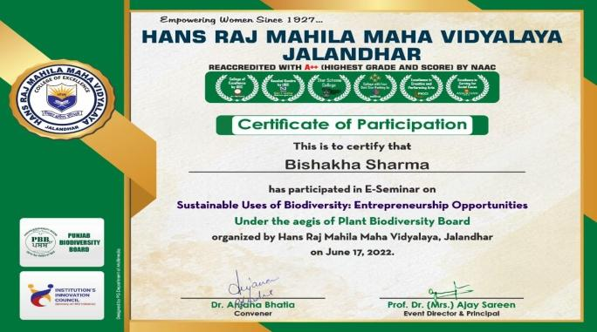
6 | Bishakha Sharma | M.Sc. SEM 4 |  | 18/20 |  | - Encouraged to participate in different online activities organised during the session.  2.Provided important questions from previous years question paper.  3.Students were motivated to enroll for MOOCS/NPTEL courses. | Article Writing Competition On Ozone Day organized in HMV College Jalandhar | 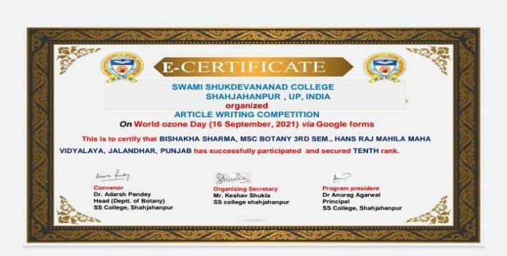
7 | Bishakha Sharma | M.Sc. SEM 4 | 25007 | 18/20 |  |  | Participation Certificate in e-Quiz Competition on World Enviornment Day In DAV College Sec-10 Chandigarh | 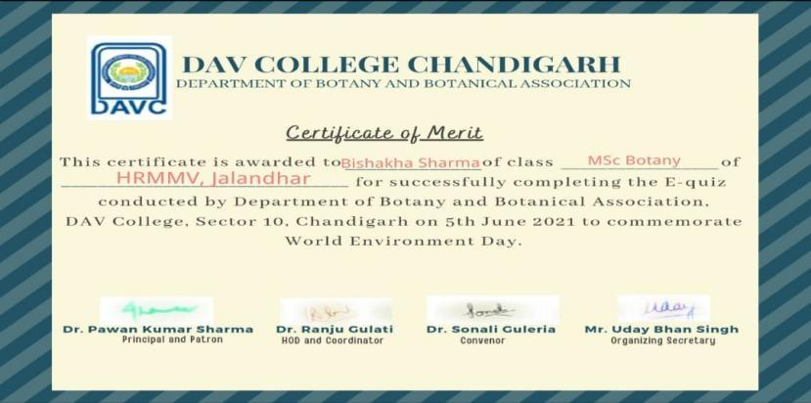
8 | Gursharn Kour | M.Sc. SEM 4 | 25001 | 19/20 |  |  | Participation Certificate for e-Training Programme In Biodiversity Governance in India organized by National Institute of Rural Development And Panchayati Raj | 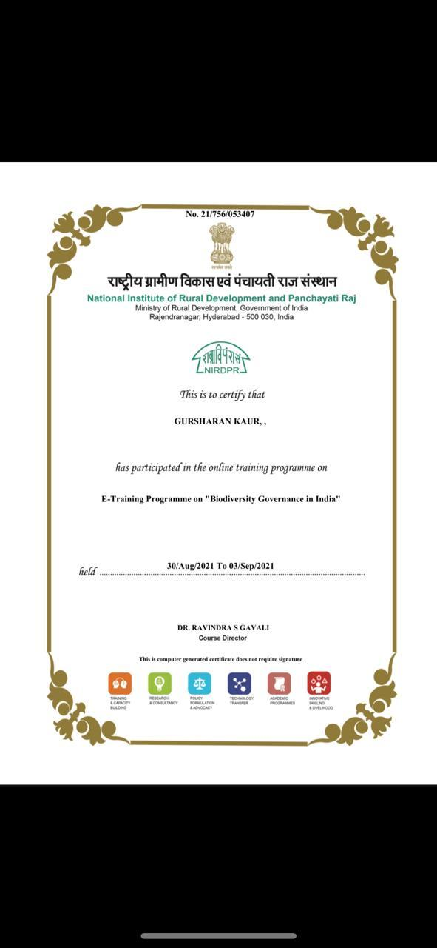
9 | Gursharn Kour | M.Sc. SEM 4 | 25001 | 19/20 |  |  | Participation In ICPBEC-2021 held in HMV College Jalandhar | 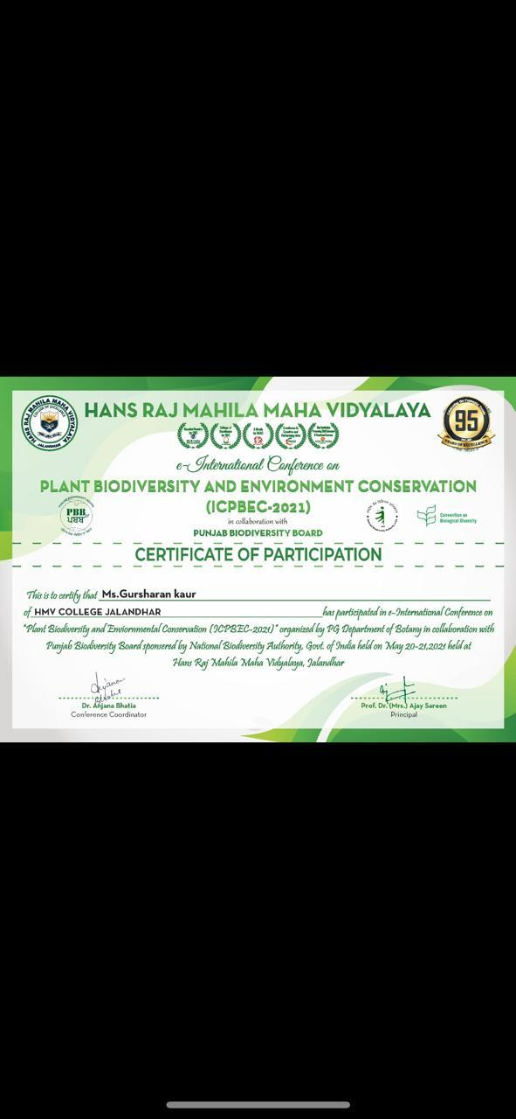
10 | Neeru | M.Sc. SEM 4 | 25004 |  |  |  | Participation certificate In ICPBEC-2021 held in HMV College Jalandhar | 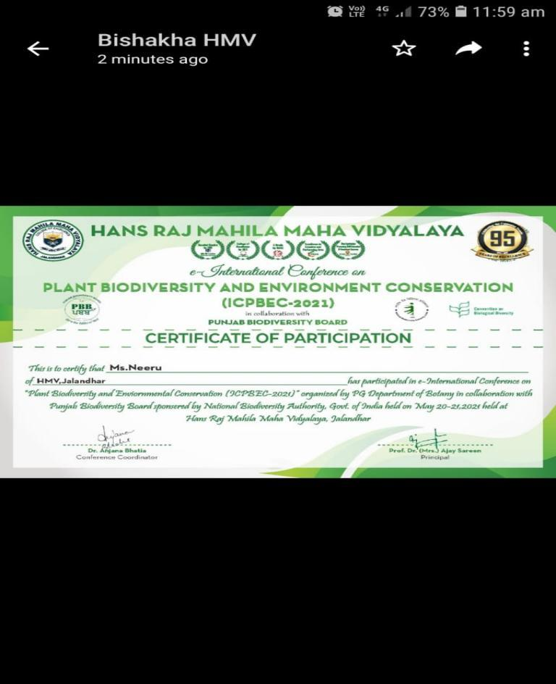
11 | Neeru | M.Sc. SEM 4 | 25004 |  |  |  | Participation Certificate for e-Training Programme In Biodiversity Governance in India organized by National Institute of Rural Development And Panchayati Raj | 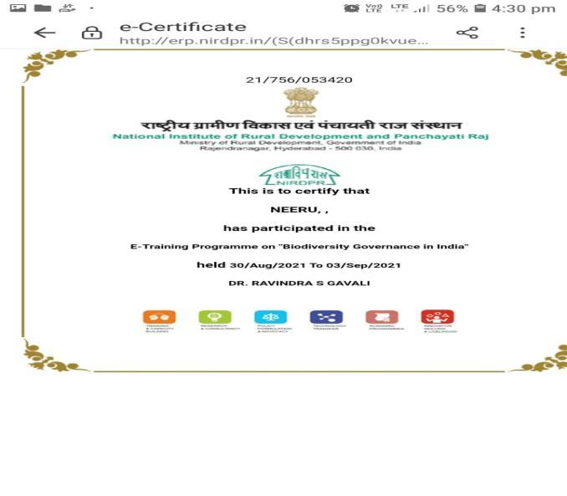
12 | Gursharan Kour | M.Sc. SEM 4 | 25001 |  |  |  | Participation Certificate in Quiz competition organized by Chanderyan Vipnet Club HMV College Jalandhar | 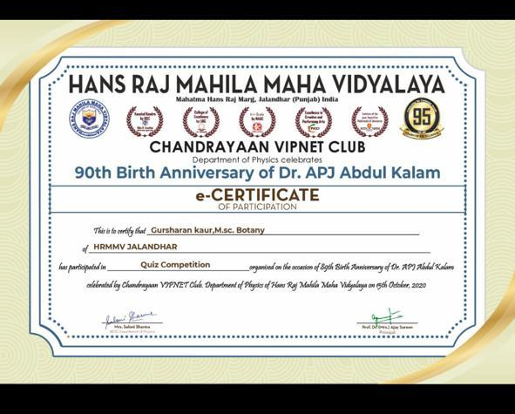
13 | Bishaka Sharma  M.Sc. SEM 4 |  | 25007 |  |  |  | Participation in Quiz competition by CHANDRYAN VIPNET CLUB HMV College Jalandhar | 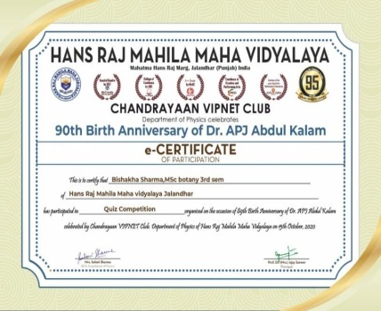
14 | Neeru  M.Sc. SEM 4 |  | 25004 |  |  |  | Participation certificate in Training Programme in NIPAM | 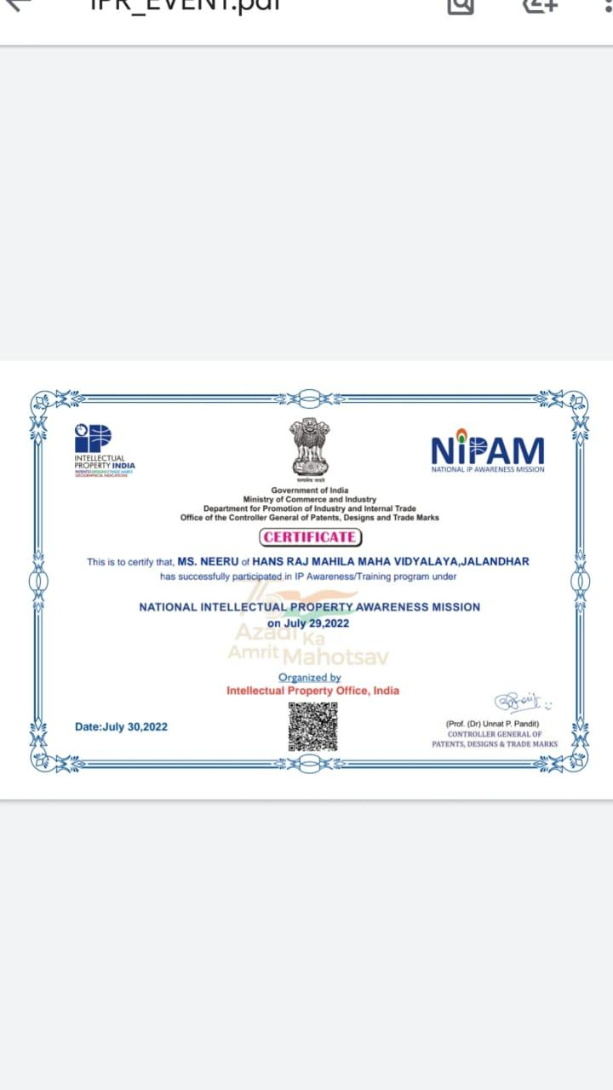
15 | Neeru  M.Sc. SEM 4 |  | 25004 |  |  |  | Participation In Scientific Rangoli In Chemcare organized by R. Venkatraman Chemical Society, HMV College Jalandhar | 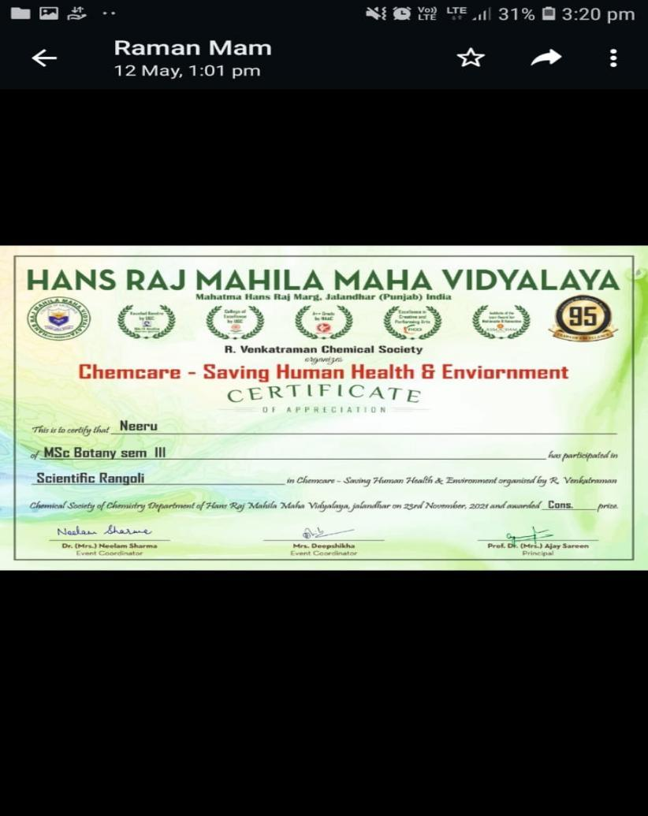

Slow Learners
Class | Marks in University Exams/House tests |  | Remedial Measures Taken | Outcome/ Achievements  Test Marks (Out of 20) |  | Proofs (if any)
B.Sc(Med) 3rdyear | 6 | 5 | - Workshop/seminar  - Mentor guidance  - Provided online lectures  - Given more assignments for preparation of final examination.  - Provided important questions from previous years question paper.  - Give additional question bank to the students | 16 | 15 | https://drive.google.com/file/d/1-E6gl3U4r2Q6tVgrLGlIDAIu4ImIFz5m/view?usp=share_link
B.Sc(Med) 3rdyear | 7 | 8 | - Workshop/seminar  - Mentor guidance  - Provided online lectures  - Given more assignments for preparation of final examination.  - Provided important questions from previous years question paper.  - Give additional question bank to the students | 17 | 18 | https://drive.google.com/file/d/1-E6gl3U4r2Q6tVgrLGlIDAIu4ImIFz5m/view?usp=share_link
B.Sc(Med) 3rdyear | 5 | 3 | - Workshop/seminar  - Mentor guidance  - Provided online lectures  - Given more assignments for preparation of final examination.  - Provided important questions from previous years question paper.  - Give additional question bank to the students | 15 | 16 | https://youtu.be/hxNwKI4BOwE
B.Sc(Med) 3rdyear | 7 | 7 | - Workshop/seminar  - Mentor guidance  - Provided online lectures  - Given more assignments for preparation of final examination.  - Provided important questions from previous years question paper.  - Give additional question bank to the students | 17 | 17 | https://youtu.be/03v9hw0NLxY
B.Sc(Med) 3rdyear | 6 | 8 | - Workshop/seminar  - Mentor guidance  - Given more assignments for preparation of final examination.  - Provided important questions from previous years question paper.  - Give additional question bank to the students | 16 | 18 | https://youtu.be/l25JHRFwb7M
B.Sc(Med) 3rdyear | 3 | 7 | - Workshop/seminar  - Mentor guidance  - Provided online lectures  - Given more assignments for preparation of final examination.  - Provided important questions from previous years question paper.  - Give additional question bank to the students | 16 | 17 | https://youtu.be/UxX_zVQD7SY
B.Sc(Med) 2nd year | 5 | 6 | - Workshop/seminar  - Mentor guidance  - Provided online lectures  - Given more assignments for preparation of final examination.  - Provided important questions from previous years question paper.  - Give additional question bank to the students | 15 | 16 | https://youtu.be/Zpw_e6PIuIw
B.Sc(Med) 2nd year | 9 | 3 | - Workshop/seminar  - Mentor guidance  - Provided online lectures  - Given more assignments for preparation of final examination.  - Provided important questions from previous years question paper.  - Give additional question bank to the students | 19 | 17 | https://youtu.be/Zpw_e6PIuIw
B.Sc(Med) 2nd year | 3 | 4 | - Workshop/seminar  - Mentor guidance  - Provided online lectures  - Given more assignments for preparation of final examination.  - Provided important questions from previous years question paper.  - Give additional question bank to the students | 16 | 14 | https://youtu.be/UxX_zVQD7SY
B.Sc(Med) 2nd year | 6 | 9 | - Workshop/seminar  - Mentor guidance  - Provided online lectures  - Given more assignments for preparation of final examination.  - Provided important questions from previous years question paper.  - Give additional question bank to the students | 16 | 19 | https://youtu.be/xm_IhpD85e4
B.Sc(Med) 2nd year | 3 | 7 | - Workshop/seminar  - Mentor guidance  - Provided online lectures  - Given more assignments for preparation of final examination.  - Provided important questions from previous years question paper.  - Give additional question bank to the students | 18 | 17 | https://youtu.be/P8MFGXTm1K8
B.Sc(Med) 1st year |  |  | - Workshop/seminar  - Mentor guidance  - Provided online lectures  - Given more assignments for preparation of final examination.  - Provided important questions from previous years question paper. |  |  | https://drive.google.com/file/d/1-E6gl3U4r2Q6tVgrLGlIDAIu4ImIFz5m/view?usp=share_link
B.Sc(Med) 1st year |  |  | - Workshop/seminar  - Mentor guidance  - Provided online lectures  - Given more assignments for preparation of final examination.  - Provided important questions from previous years question paper. |  |  | https://drive.google.com/file/d/1-E6gl3U4r2Q6tVgrLGlIDAIu4ImIFz5m/view?usp=share_link
B.Sc(Med) 1st year |  |  | - Workshop/seminar  - Mentor guidance  - Provided online lectures  - Given more assignments for preparation of final examination.  - Provided important questions from previous years question paper.  - Give additional question bank to the students |  |  | https://youtu.be/03v9hw0NLxY
B.Sc(Med) 1st year |  |  | - Workshop/seminar  - Mentor guidance  - Provided online lectures  - Given more assignments for preparation of final examination.  - Provided important questions from previous years question paper. |  |  | https://drive.google.com/file/d/1-E6gl3U4r2Q6tVgrLGlIDAIu4ImIFz5m/view?usp=share_link

